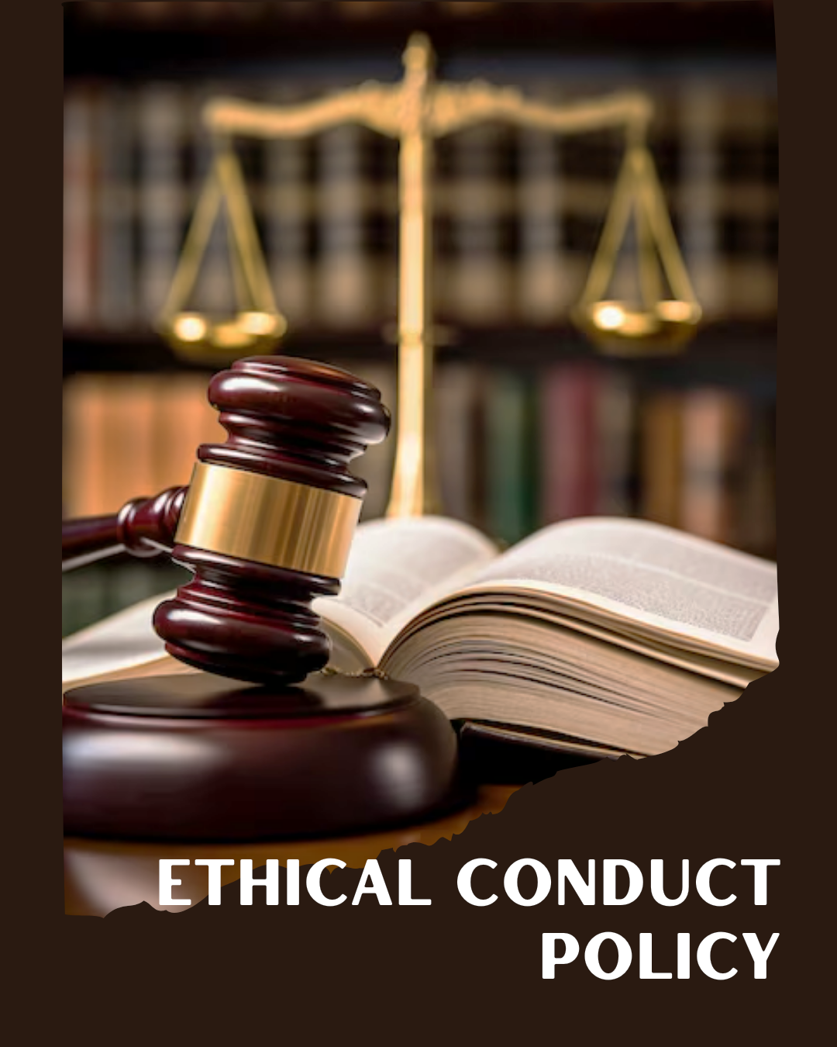
ARSH FASHIONS PVT. LTD.

A UNIT OF PERMESHWAR FASHIONS IMPEX PVT. LTD.

TABLE OF CONTENTS
PREFACE 2
SCOPE 2
POLICY DECLARATION 2
INITIATIVES AND TARGETS IN ALIGNMENT WITH SDGs 3
PERFORMANCE REPORTING 4
REVIEW MECHANISM 4

PREFACE

At Arsh Fashions, we are committed to uphold the highest standards of ethical conduct in all aspects of our operations. Our Ethical Conduct Policy reflects our dedication to integrity, transparency, and accountability, ensuring that our business practices align with our core values and industry best practices. This policy provides a framework for making ethical decisions and reinforces our commitment to fair and responsible behavior, both within our organization and in our interactions with external partners. By adhering to this policy, we aim to foster a respectful and principled work environment that supports our mission and sustains our reputation as a leading garment producer.

SCOPE

This Policy is applicable to following sites and all of its employees, workers, sub-contractors and other stakeholders:

Sr. No. | Site | Address
1 | ARSH FASHOINS Pvt. Ltd. | Plot No.194, IInd Phase, G.I.D.C., Vapi - 396195,  Gujarat, India.

POLICY DECLARATION

At Arsh Fashions, we are devoted to ethical excellence in every facet of our operations. This policy mandates that all individuals associated with our company uphold principles of honesty, integrity, and transparency. Our commitment to ethical conduct ensures compliance with legal standards and fosters a culture of accountability and respect throughout our organization. The goal is to embed ethical practices across all operations, building on the baseline set in year 2023.

INITIATIVES AND TARGETS IN ALIGNMENT WITH SDGs

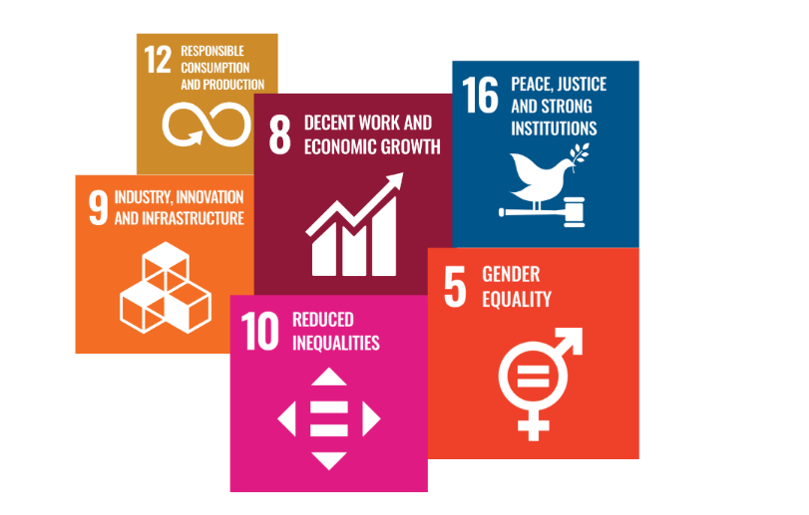

- Implement a comprehensive anti-corruption training program for all employees, aimed at increasing awareness and understanding of anti-corruption policies and practices.
- Achieve 100% completion of anti-corruption training for all employees by year 2030.
- Establish and enforce clear guidelines for identifying and managing conflicts of interest, including regular reviews of employee disclosures.
- Ensure that 100% of employees complete a conflict of interest disclosure form by year 2030.
- Develop and maintain robust internal controls and auditing procedures to detect and prevent fraudulent activities.
- Reduce instances of detected fraud by 15% through enhanced monitoring and control measures by year 2030.
- Create a confidential and accessible whistleblower reporting system with clear procedures for handling reports and protecting whistleblowers from retaliation.
- Resolve 90% of whistleblower complaints within 60 days and maintain zero retaliation incidents by year 2030
- Implement a comprehensive anti-money laundering (AML) policy with regular training for employees on recognizing and reporting suspicious activities.
- Achieve 100% compliance with AML reporting requirements and conduct at least two audits per year to ensure policy adherence by year 2030.
- Develop and enforce policies to prevent and address anti-competitive behavior, including regular training on fair competition practices.
- Conduct annual reviews of competitive practices and achieve zero violations of anti-competitive regulations by year 2030
- Establish guidelines for ethical marketing that ensure all advertising and promotional materials are truthful, transparent, and not misleading.
- Regularly Review and approve 100% of marketing materials before publication to ensure compliance with ethical standards by year 2030.
- Implement a comprehensive information security management system (ISMS) that includes regular risk assessments and updates to safeguard sensitive data.
- Achieve and maintain 100% compliance with information security policies and perform security audits to identify and address vulnerabilities by year 2030.

PERFORMANCE REPORTING

The performance reporting will be conducted annually, providing a detailed assessment of compliance with ethical standards and regulations. The report will evaluate the effectiveness of anti-corruption measures, conflict of interest management, and fraud prevention strategies. It will also review the implementation of whistleblower protections, anti-money laundering controls, and adherence to ethical marketing practices. Additionally, the report will analyze data on anti-competitive practices and information security, ensuring that all ethical conduct policies are effectively enforced and aligned with organizational goals.

REVIEW MECHANISM

The Ethical Conduct Policy will be reviewed annually by the Chief Ethics Officer to ensure ongoing relevance and effectiveness. This review process will involve evaluating adherence to ethical standards, analyzing data on compliance issues, and incorporating feedback from internal audits and stakeholder input. Adjustments to the policy will be made as needed to address emerging challenges and align with best practices.

REV. No. 01

EFFECTIVE FROM: 01.01.2024 NEXT REVIEW DATE: 01.01.2025

APPROVED BY: PRESIDENT - OPERATIONS

